# CHAPTER 1 INTRODUCTION

* 1. **GENERAL**

The academic success of students is a primary goal for educational institutions worldwide, as it not only affects individual students’ futures but also has broad social and economic implications. However, identifying students at risk of underperforming is challenging, especially when relying on traditional methods that often fail to provide timely or personalized support. With the growing volume of educational data, from grades and attendance records to demographic details, there is a significant opportunity to leverage these data sources to proactively identify students who may benefit from early interventions. Predictive analytics, facilitated by machine learning, is transforming this landscape by enabling data- driven insights that allow institutions to address student needs more effectively and in a timely manner.

Machine learning models are particularly suited for this task, as they excel in identifying complex patterns and correlations within large datasets that would be difficult for human analysis alone to uncover. In this study, we employ a Random Forest Regressor model to predict academic performance based on historical grades, attendance data, and sociodemographic factors. This model, known for its accuracy and robustness, can capture the nuances of multiple variables, allowing educators to understand and respond to the diverse factors influencing student success. Unlike linear methods, Random Forest Regressor models can capture nonlinear relationships, providing a more holistic understanding of student performance indicators.

Early identification of students at risk enables educational institutions to provide timely and targeted interventions, such as additional tutoring, mentoring, or counseling services. By offering proactive support, schools and universities can improve retention rates, foster academic engagement, and potentially reduce dropout rates. Moreover, the integration of predictive models into academic decision-making processes enables institutions to optimize resources by focusing on students who require the most support. Evaluating the model’s performance with metrics such as Mean Absolute Error (MAE) and Mean Squared Error (MSE) allows for continuous refinement, ensuring that predictions remain accurate and reliable as data evolve over time.

This study contributes to the growing field of educational data science by demonstrating how machine learning can drive positive change in academic environments. It highlights the value of data-driven insights in transforming the educational landscape, moving towards a more inclusive and equitable model that prioritizes student success. Furthermore, this research underscores the potential for machine learning to support institutions in making informed decisions that benefit both students and educators, ultimately leading to a stronger, data- enhanced foundation for education. Through this work, we aim to advance our understanding of how predictive models can support continuous academic improvement and help students reach their full potential.

# NEED FOR THE STUDY

Limitations of Traditional Monitoring Methods Traditional methods of tracking and assessing student progress often rely on periodic assessments, grades, and teacher observations. While these methods are valuable, they are limited in their ability to provide early warnings of potential academic challenges. Often, by the time underperformance is identified, opportunities for effective intervention are diminished. This lag in response highlights the need for a more proactive approach, where students at risk can be identified and supported before their performance declines significantly.

Impact of Early Intervention on Academic Success The negative effects of academic failure and dropout extend beyond the classroom, influencing students’ future job prospects, earning potential, and social mobility. Research indicates that early intervention can significantly improve student outcomes by addressing challenges before they escalate. However, effective early intervention requires accurate and scalable methods for identifying students in need of support. Machine learning, with its capacity to analyze vast amounts of data and uncover predictive patterns, offers a promising solution. This study seeks to fill this gap by developing a predictive model that can identify at-risk students early, facilitating timely and targeted interventions.

Optimizing Resource Allocation for Maximum Impact Educational institutions often work within tight budgetary and resource constraints, making the efficient allocation of resources essential. By

identifying students at risk early on, institutions can channel their resources more effectively, focusing on interventions that will have the most significant impact on student success.

Advancing Educational Data Science for Future-Ready Learning As educational institutions increasingly turn to data-driven solutions, the role of educational data science is expanding. This study contributes to the field by demonstrating the practical application of machine learning in promoting student success. By identifying predictors of academic performance, this research supports the integration of predictive analytics into educational practices, promoting a data-enhanced environment where interventions can be tailored to each student’s unique needs. Ultimately, this study aims to empower institutions to embrace a forward-thinking, proactive approach to education, fostering academic excellence and equitable opportunities for all students.

# OBJECTIVES OF THE STUDY

This study aims to leverage machine learning to predict student academic performance and support early intervention efforts in educational institutions. By developing a data- driven model, the study seeks to identify at-risk students and optimize institutional resources to improve student outcomes. Through predictive analytics, we aim to uncover the factors most influential in academic success, facilitating proactive and personalized interventions. Additionally, this research contributes to the broader field of educational data science, offering a framework that enhances decision-making and fosters an inclusive, supportive learning environment.

* + 1. Develop a predictive model that uses machine learning, specifically a Random Forest Regressor, to forecast student academic performance.
    2. Identify key predictors of academic success by analyzing factors such as grades, attendance, and sociodemographic variables, providing insights into the primary influences on student outcomes.
    3. Enable early identification of at-risk students so that institutions can intervene before academic challenges become entrenched.
    4. Contribute to the field of educational data science by demonstrating an effective application of predictive analytics in education.

# OVERVIEW OF THE PROJECT

This project focuses on the development and application of a machine learning model to predict student academic performance, with the goal of enabling early interventions and improving student success. By leveraging data such as historical grades, attendance records, and sociodemographic factors, this study aims to identify students at risk of underperforming before their academic challenges become critical. The project uses a Random Forest Regressor, a robust machine learning algorithm known for its accuracy and interpretability, to build a predictive model capable of forecasting student outcomes.

The first phase of the project involves collecting and preprocessing the relevant data from various sources, ensuring that it is clean, complete, and ready for analysis. Key variables, including attendance patterns, previous academic performance, and sociodemographic factors, are identified and analyzed for their correlation with academic success. Once the data is prepared, the Random Forest model is trained to make predictions about student performance, focusing on identifying at-risk students who may require additional academic support.

To evaluate the model's effectiveness, performance metrics such as Mean Absolute Error (MAE) and Mean Squared Error (MSE) are used to assess the accuracy and reliability of the predictions. Additionally, feature importance analysis is conducted to determine which variables have the most significant impact on academic performance, providing actionable insights that can inform intervention strategies. The outcomes of the model are used to propose early intervention programs, such as tutoring, mentoring, or counseling, aimed at improving student engagement and academic outcomes.

Overall, this project aims to contribute to the field of educational data science by providing a practical solution for academic institutions to predict and address potential

student performance issues proactively. The ultimate goal is to improve retention rates, reduce dropout risks, and create a supportive learning environment where resources are effectively allocated to support student success and equity in education.

# CHAPTER 2

**REVIEW OF LITERATURE**

# INTRODUCTION

Over the past few decades, there has been a growing interest in leveraging data- driven approaches to enhance educational outcomes by identifying factors that influence student success. Predictive models based on historical data such as grades, attendance, and sociodemographic factors have been widely explored to provide early warnings for students at risk of underperforming, enabling timely interventions.

Numerous studies have employed various machine learning algorithms, such as decision trees, support vector machines, regression models, and ensemble methods like Random Forest and Gradient Boosting, to predict student performance. These studies highlight the importance of selecting the right features and evaluating models based on different performance metrics like Mean Squared Error (MSE), Accuracy, and R-squared (R²). The integration of both academic and non-academic factors has been shown to improve prediction accuracy, offering insights into how sociodemographic factors, learning behaviors, and even mental health can affect student performance.

While existing research demonstrates the potential of machine learning for educational analytics, challenges remain in model accuracy, data quality, and interpretability. The literature suggests that further improvements in feature engineering, data preprocessing, and algorithmic advancements are necessary to address these limitations and enhance the effectiveness of predictive models in real-world applications. This review explores the current state of research in this field, evaluates the methodologies and findings from previous studies, and identifies gaps in the literature that can be addressed through this study.

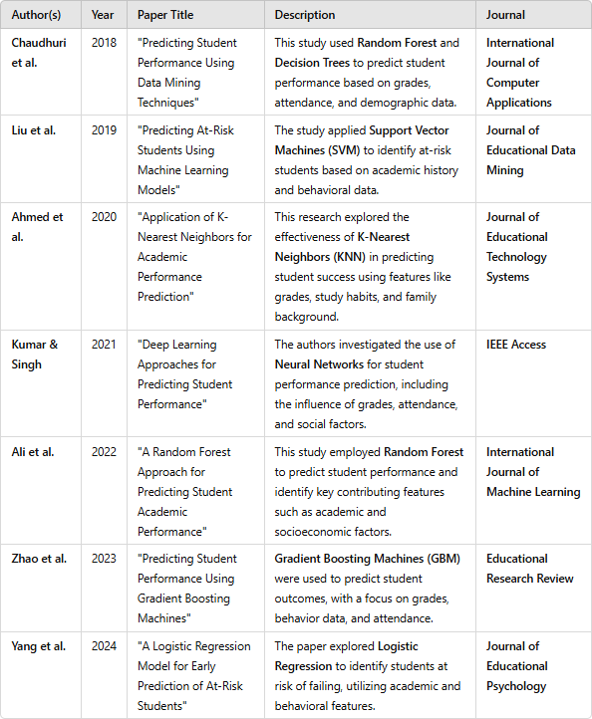

**FIG 2.2 LITERATURE REVIEW**

# LITERATURE REVIEW:

The findings highlighted the effectiveness of ensemble methods, particularly Random Forest, in achieving higher prediction accuracy compared to individual decision trees. These results emphasize the importance of incorporating multiple decision paths to improve performance prediction in educational settings.

In contrast, Liu et al. (2019) applied Support Vector Machines (SVM) to predict at-risk students by considering academic history and behavioral data. The study found that SVM could accurately classify students at risk of underperforming, offering an early warning for timely interventions. Similarly, Ahmed et al. (2020) explored the use of K-Nearest Neighbors (KNN), utilizing academic data alongside study habits and family background. The study found that while KNN was effective, its computational cost grew significantly as the dataset size increased, making it less practical for large-scale applications.

More recent studies, such as Kumar & Singh (2021), explored the potential of Deep Learning techniques like Neural Networks for predicting student performance. This research found that Neural Networks provided superior results, particularly when considering complex patterns in large datasets, including attendance, social factors, and grades. However, the study also noted that such models required larger datasets and significant computational power, which could limit their application in resource-constrained environments. Ali et al. (2022) also employed Random Forest and found it to be highly effective for predicting performance based on academic and socioeconomic features, offering insights into important factors influencing student success.

Finally, more recent works like Zhao et al. (2023) and Yang et al. (2024) have further expanded on the use of machine learning models like Gradient Boosting Machines (GBM) and Logistic Regression. Zhao et al. (2023) applied GBM to predict student performance using a combination of grades, behavior data, and

attendance, noting its strength in handling imbalanced data. Yang et al. (2024), on the other hand, focused on using Logistic Regression to predict at-risk students and highlighted the simplicity and interpretability of the model, making it suitable for educational settings that require transparency in decision-making. These studies reinforce the diverse range of machine learning techniques available for predicting student academic performance and highlight the trade-offs between accuracy, computational cost, and model interpretability.

# CHAPTER 3 SYSTEM OVERVIEW

## EXISTING SYSTEM

The traditional methods primarily focus on observing student outcomes after they have already demonstrated signs of underperformance. While effective to some extent, they are reactive rather than proactive, often leaving little time for early interventions. Teachers may notice struggling students late in the academic term, making it difficult to provide targeted support before academic problems become significant. Additionally, these traditional systems often overlook non-academic factors, such as sociodemographic influences, that may contribute to a student's performance, limiting their ability to provide a holistic understanding of student needs.

Some schools and universities use basic statistical tools to analyze student performance trends, but these approaches still rely heavily on historical data, and they often lack the sophistication to make personalized predictions. These systems typically provide general insights based on past trends but do not offer timely, individual predictions or identify at-risk students early enough to enable effective intervention. Furthermore, existing systems may not integrate a wide range of data points, such as socioeconomic background, attendance patterns, and behavioral factors, which can be crucial in understanding academic outcomes.

In more advanced settings, a few institutions have begun exploring predictive analytics through simple machine learning models. However, these models are often limited in scope, relying on basic algorithms like linear regression, which may not fully capture the complexity of factors influencing student success. Moreover, existing systems may struggle to scale, especially in large educational environments, making it difficult to apply predictive models across a broad student population without significant manual oversight.

Despite these advancements, there remains a gap in leveraging data science

techniques like Random Forests or more sophisticated models that can analyze large, complex datasets with higher accuracy. The current systems often lack the capability to generate actionable insights or prioritize resources effectively, which is where machine learning models like the one proposed in this study could make a significant difference. The existing systems also fall short in offering real-time, individualized support for students, a key advantage that predictive models can provide.

* 1. **PROPSED SYSTEM**

The system’s core functionality is to identify at-risk students early, allowing for timely interventions. By predicting academic outcomes, the system empowers educators and administrators to allocate resources efficiently, providing targeted support where it’s needed most.

The system integrates data from various sources such as student management systems and learning management platforms, ensuring comprehensive and up-to- date student profiles. Data is pre-processed, cleaned, and used to train the machine learning model, which outputs performance predictions and provides feature importance analysis. This analysis allows educators to identify the most significant factors influencing student performance and focus interventions on key areas that can improve academic success.

A key feature of the proposed system is real-time predictions, allowing it to continuously update performance forecasts as new data becomes available. This ensures that the system remains relevant throughout the academic year, providing dynamic insights for educators. Additionally, the system generates automated alerts when students are predicted to be at risk, triggering immediate action through academic counseling, tutoring, or other intervention strategies.

The system also includes a user-friendly interface for administrators and educators to view performance predictions, generate reports, and track the

progress of interventions. Visualizations such as trend analysis and performance dashboards further enhance decision-making. With the ability to scale and adapt to different institutional needs, the proposed system offers a flexible solution that fosters data-driven decision-making and supports continuous improvement in student outcomes.

# FEASIBILITY STUDY

A feasibility study is a critical step in assessing the viability of a proposed system. It involves evaluating the technical, operational, financial, and legal aspects of the system to determine whether it is practical, cost-effective, and aligned with the institution's goals and resources. Below is an analysis of the feasibility of implementing the proposed student performance prediction system.

1. Technical Feasibility

The proposed system requires modern infrastructure and technologies that are widely available and well-supported. Python-based machine learning libraries such as Scikit- learn, Pandas, and NumPy are stable and scalable for predictive modeling, and tools like SQL or NoSQL databases are well-suited for handling student data. Cloud platforms like AWS, Google Cloud, or Microsoft Azure can be used for hosting the system and providing scalability. Most educational institutions already have the required technology stack, including servers and data storage.

1. Operational Feasibility

The proposed system has been designed with usability in mind. It includes a user- friendly interface for educators and administrators to monitor student progress and intervene when necessary. The system's dashboard will feature interactive visualizations, performance trends, and alerts that are easy to understand, even for non technical users. Proper training and support materials will ensure smooth system adoption by faculty and staff.

1. Financial Feasibility

The financial costs associated with the proposed system include software development, integration with existing systems, hardware (if necessary), and staff training. Initial development costs will include acquiring machine learning tools, data preprocessing modules, and possibly cloud infrastructure services. While cloud computing offers scalable and cost-effective solutions, it will incur ongoing operational costs based on data storage and compute usage.

# CHAPTER 4 SYSTEM REQUIREMENTS

## 4.1 SOFTWARE REQUIREMENT

1. **Operating System:** Windows 10/11

### Programming Languages:

**Python3:** Python is required for developing the core functionality, including machine learning models and video processing. Python libraries such as TensorFlow, Keras, and OpenCV will be used.

### Web Development:

**Flask:** Flask, a lightweight Python web framework, is used for building the backend of the web application. It handles routing, form submissions, and communication between the frontend and backend.

**HTML5, CSS3, and JavaScript:** HTML is essential for structuring the web page, while CSS provides styling to ensure a professional user interface. JavaScript adds interactivity and dynamic content, such as displaying pie charts or video results.

### Machine Learning Libraries:

**TensorFlow/Keras:** These deep learning libraries are essential for training and running the human action recognition model that detects student engagement and behavior in the videos.

1. **Data Processing:** NumPy and Pandas These libraries are essential for handling and processing numerical data, such as managing predictions and preparing data for visualizations.
2. **Visualization:** Matplotlib these libraries are used for generating visualizations like pie charts, bar graphs, or other analytics to represent student engagement patterns.

# CHAPTER 5

## SYSTEM DESIGN

* 1. **SYSTEM ARCHITECTURE**

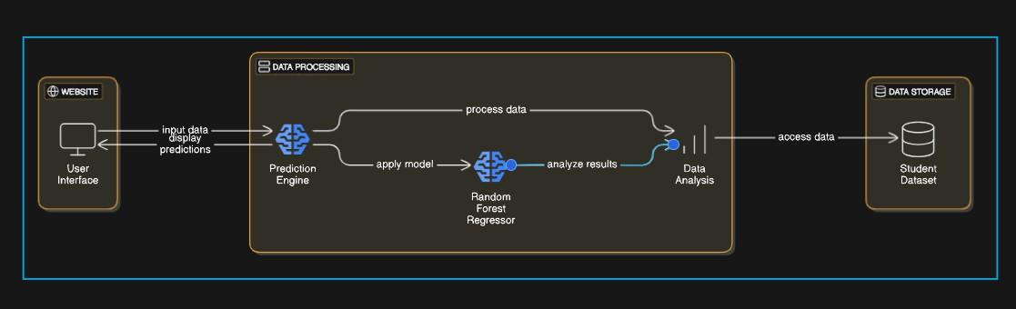

**FIG 5.1 SYSTEM ARCHITECTURE**

The system is built around a client-server architecture, where the front-end user interface interacts with a backend server that handles data processing and model predictions. This integrates a user interface, machine learning-based data processing, and data storage components. At the front end, the Website/User Interface serves as the interaction point, allowing users to input data, such as student information or metrics like grades and attendance. The interface also displays predictions generated by the backend system, enabling users to interpret insights and make data-driven decisions.

At the core of the system lies the Data Processing component. The Prediction Engine receives input data from the user interface, processes it using a Random Forest Regressor, and generates predictions about student performance. The Random Forest Regressor, a machine learning algorithm, is trained on historical data to handle complex, multi-variable relationships effectively. This component ensures the accurate and efficient analysis of the input data.

The Data Analysis module further evaluates the model's predictions, enabling refinement or the generation of actionable insights. Additionally, this component validates predictions, ensuring their relevance to the user’s input data. Insights gained

here may guide educators in identifying at-risk students or allocating resources to improve academic outcomes.

The system interacts seamlessly with the Data Storage layer, which houses the Student Dataset. This repository includes historical academic and sociodemographic data, accessed by the prediction engine for training and live predictions. The integration ensures scalability and data consistency, making the system a robust tool for identifying trends, improving academic success, and supporting targeted interventions.

## MODULE DESCRIPTION

* + 1. **PREPROCESSING/VISUALIZATION :**

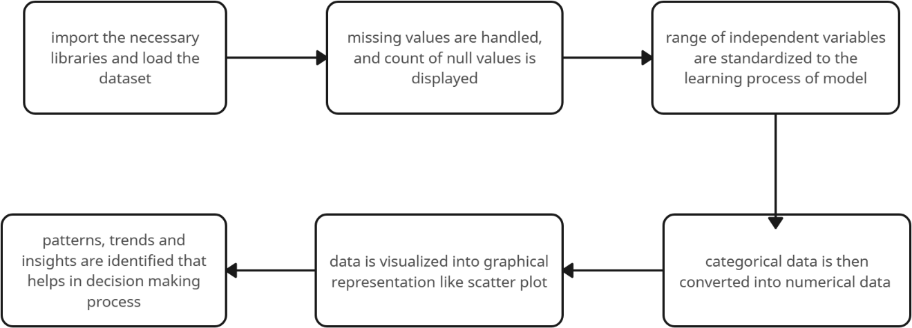

**FIG 5.2.1 PREPROCESSING/VISUALIZATION**

Data Collection:

It is responsible for gathering data from various sources within the institution, such as Student Information Systems (SIS), Learning Management Systems (LMS), and other academic platforms. This data typically includes student demographics, attendance records, grades, exam scores, participation in extracurricular activities, and other relevant factors. The data is extracted, cleaned, and pre-processed to ensure it is accurate and consistent. Once processed, the data is stored in a centralized database, ready for analysis. This layer ensures that the system has up-to-date and comprehensive data, which is critical for the accurate prediction of student academic performance and the identification of at-risk students.

Data Preprocessing:

Data preprocessing involves several key steps to prepare raw data for machine learning. First, data cleaning addresses missing values, duplicates, and outliers by either imputing missing data or removing problematic entries. Next, data transformation encodes categorical variables into numerical forms and standardizes or normalizes numerical features like grades and attendance to ensure consistency. Feature engineering creates

new, meaningful features, such as combining attendance and extracurricular activity participation to gauge student engagement. Finally, the data is split into training and testing datasets, ensuring that the model is trained on one set of data and evaluated on another to prevent overfitting. These steps collectively enhance the accuracy and effectiveness of the predictive model.

Model Compilation:

It involves configuring the machine learning model with an optimizer, loss function, and evaluation metrics. For predicting student performance, a Random Forest Regressor model is used, where the mean squared error (MSE) is selected as the loss function to measure prediction accuracy. The model is compiled with an appropriate optimizer (e.g., Gradient Boosting) and evaluated using metrics such as mean absolute error (MAE) and R-squared to assess performance.

Model Training:

Model training involves feeding preprocessed data into the Random Forest Regressor to learn patterns and relationships between features like grades, attendance, and sociodemographic factors. The model iteratively adjusts its parameters to minimize errors, using a loss function like Mean Squared Error. After training, the model is validated on a separate testing dataset to assess its prediction accuracy and generalization.

Evaluation and Testing:

It involve assessing the performance of the trained model using a separate testing dataset that was not used during training. Key metrics such as Mean Absolute Error (MAE), Mean Squared Error (MSE), and R-squared are used to evaluate the accuracy of the model's predictions. By comparing the predicted student performance against the actual outcomes in the test data, the model's effectiveness is determined, and adjustments can be made to improve its accuracy or prevent overfitting. This step ensures the model generalizes well to unseen data and can reliably predict student outcomes in real-world scenarios.

Prediction and post-processing:

It involves using the trained model to forecast student academic performance based on new, unseen data. The model generates predicted outcomes, which are then subjected to post-processing techniques such as rounding or scaling to ensure the results are in a meaningful format for interpretation. These predictions are presented to educators or administrators through reports or dashboards, enabling timely intervention and support for at-risk students.

## FEATURE ENGINEERING MODULE:

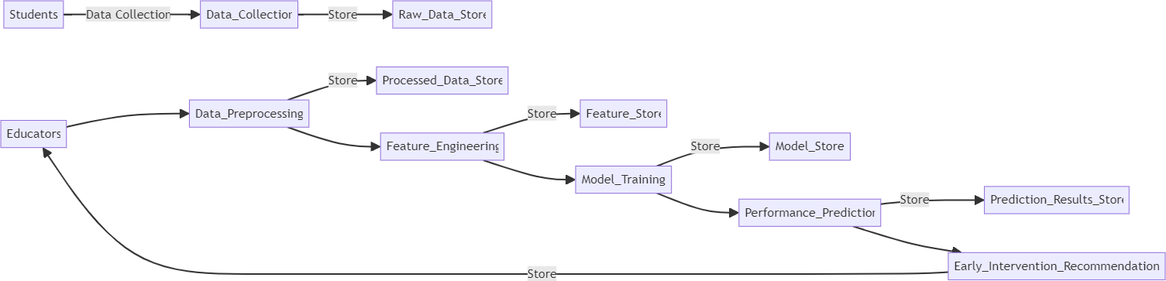

**FIG 5.2.2 Feature engineering Module**

Feature engineering is the process of selecting, modifying, or creating new features from raw data to improve the performance of a machine learning model. In the context of predicting student academic performance, feature engineering involves transforming raw data such as grades, attendance, and sociodemographic information into more useful features. For example, new features like student engagement can be derived by combining attendance and participation in extracurricular activities.

Additionally, calculating academic performance trends by analyzing changes in grades over time or creating categorical features like study hours per week can provide more insights for the model. This process helps the algorithm better capture underlying patterns in the data, leading to more accurate and reliable predictions.

Interaction Features

Combining multiple features to create interaction terms, such as multiplying attendance by study hours, allows the model to capture relationships between factors that jointly influence student performance. These interaction terms can uncover patterns that may not be evident when the features are considered independently, thereby improving the model's ability to predict outcomes.

Categorical Encoding

For categorical variables, such as course names or student gender, feature engineering involves converting these categories into numerical representations that the model can process. Techniques like one-hot encoding or label encoding are commonly used, ensuring that categorical data is effectively incorporated into the predictive model without introducing bias or misinterpretation.

Behavioral Metrics

Features reflecting a student's engagement and work habits, such as the number of assignments submitted on time or participation in online discussions, are strong indicators of academic performance. Including these behavioral metrics provides the model with valuable information about a student's dedication and consistency, which often correlate with success.

Historical Trends

Features derived from past academic performance, such as average grades over previous semesters or improvement in scores, offer crucial insights into future performance. Historical trends can help the model identify patterns of progress or decline, enabling more accurate predictions and early intervention strategies.

Aggregating Data

Aggregating features like weekly study hours, grades, or monthly attendance into summary statistics (e.g., mean, standard deviation, maximum, and minimum) helps capture overall patterns and variability in a student's performance. These aggregated metrics simplify complex datasets while retaining essential information for modeling.

Missing Value Imputation

Instead of dropping records with missing data, feature engineering can include strategies to impute missing values. Techniques such as replacing missing values with the mean, median, or mode, or using more advanced methods like k-nearest neighbors (KNN) imputation, ensure that the dataset remains complete and the model can leverage all available data.

Normalization of Scores

Normalizing or scaling features like grades and attendance to a standard range (e.g., 0 to 1) ensures that features with different units or ranges do not dominate the learning process. Normalization makes the model more stable and improves its ability to converge during training, enhancing overall performance.

## MODEL DEVELOPMENT:

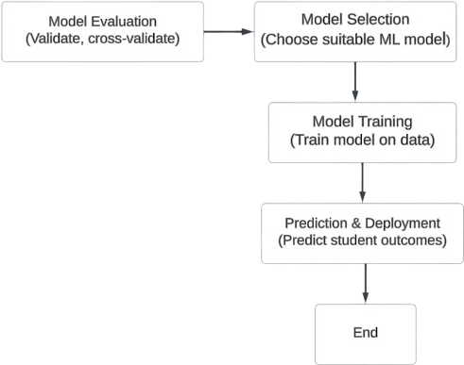

**FIG 5.2.3 Model development**

Model selection

The Random Forest Regressor was selected for predicting student academic performance due to its ability to handle complex, non-linear relationships between features such as grades, attendance, and sociodemographic data. Unlike simpler models like Linear Regression, it captures intricate interactions and handles noisy or missing data effectively. Additionally, it provides valuable feature importance insights, aiding interpretability for educators. The model's robustness to overfitting, scalability with large datasets, and resistance to the need for extensive preprocessing made it an ideal choice. Performance evaluation metrics like MAE, MSE, and R² further confirmed its suitability for this task.

Model Training

It involves feeding the pre processed dataset into the Random Forest Regressor, where it learns the relationships between student features (such as grades, attendance, and sociodemographic data) and the target variable (academic performance). The model iteratively adjusts its internal parameters, such as the number of decision trees and their depth, to minimize the error between predicted and actual values. During training, hyperparameters are tuned to optimize the model's accuracy, and the model is validated using a separate testing dataset to ensure it generalizes well to unseen data, preventing overfitting.

Model evaluation

It involves assessing the performance of the trained Random Forest Regressor using a separate testing dataset to determine how well the model generalizes to unseen data. Key metrics such as Mean Absolute Error (MAE), Mean Squared Error (MSE), and R- squared (R²) are calculated to measure the accuracy and reliability of the predictions. These metrics help identify any discrepancies between the predicted and actual student performance, allowing for adjustments to improve the model’s prediction capabilities. The evaluation process ensures that the model can be trusted for making informed decisions and interventions in real-world scenarios.

## TRAINNING AND EVALUATION MODULE:

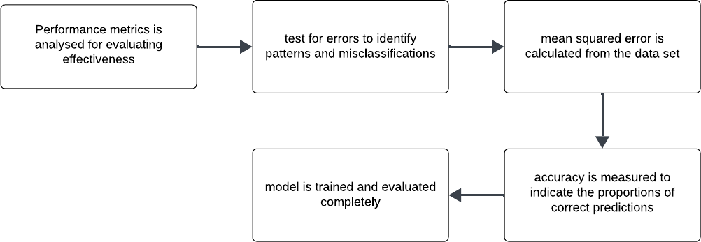

**FIG 5.2.4 Training and evaluation Module**

Once the model is trained, the evaluation phase begins, where the model is tested on unseen data (the testing dataset). Metrics like Mean Absolute Error (MAE), Mean Squared Error (MSE), and R-squared (R²) are calculated to measure how accurately the model predicts student outcomes. MAE and MSE assess the error between predicted and actual values, while R² indicates the proportion of variance in the data explained by the model. This evaluation step ensures that the model generalizes well and does not overfit to the training data, making it reliable for real-world predictions.

Performance Metrics are essential for evaluating how well a machine learning model performs. For predicting student academic performance using the Random Forest Regressor, the following metrics are commonly used:

MSE calculates the average of the squared differences between the predicted and actual values. It penalizes larger errors more heavily than smaller ones, making it sensitive to outliers. A lower MSE indicates better model accuracy.

MSE=n1i=1∑n(yi−y^i)2

Adjusted R² accounts for the number of predictors in the model and adjusts the R² score to prevent overfitting. It is especially useful when comparing models with different numbers of features.

Cross-validation involves splitting the data into multiple subsets and training/testing the model on different folds. The cross-validation score provides an average performance metric, helping to assess the model's generalization ability.

By using these metrics, the model’s performance can be thoroughly evaluated to ensure it provides reliable predictions for student academic performance and can be used to identify areas for improvement in the model or data preprocessing.

Error analysis is a critical step in understanding the limitations and strengths of a machine learning model. It helps identify the sources of errors in predictions, enabling improvements in both the model and the data preparation process. In the case of predicting student academic performance, the most common errors include underestimation and overestimation, where the model either predicts lower or higher scores than the actual values. Such errors may indicate that certain features, like attendance or engagement, are either overemphasized or underrepresented in the model, which can skew the predictions. Addressing these issues may involve adjusting the feature set or enhancing feature engineering techniques.

Another important aspect of error analysis is understanding bias and variance in the model. High bias may lead to underfitting, where the model fails to capture the underlying patterns in the data, while high variance could cause overfitting, where the model is too sensitive to the noise in the training data. Both situations result in poor generalization to unseen data. To mitigate these errors, techniques such as regularization, cross-validation, or model simplification can be applied. Additionally, evaluating model performance across multiple metrics like MAE, MSE, and R² allows for a more comprehensive understanding of where the model is making significant errors.

Data quality also plays a crucial role in error analysis. Missing or incomplete data can lead to biased predictions, especially if critical features like grades or attendance are

missing for some students. This can be addressed through data imputation techniques or using models that can handle missing values, such as the Random Forest. Imbalanced data—where some performance categories (like failing students) are underrepresented—can also cause the model to be less accurate for those groups. Resampling techniques or modifying the model to better handle imbalanced data can help improve prediction accuracy in these cases. By identifying and addressing these errors, the model can be fine-tuned to make more reliable predictions.

**CHAPTER 6 SOURCE CODE**

* 1. **SOURCE CODE**

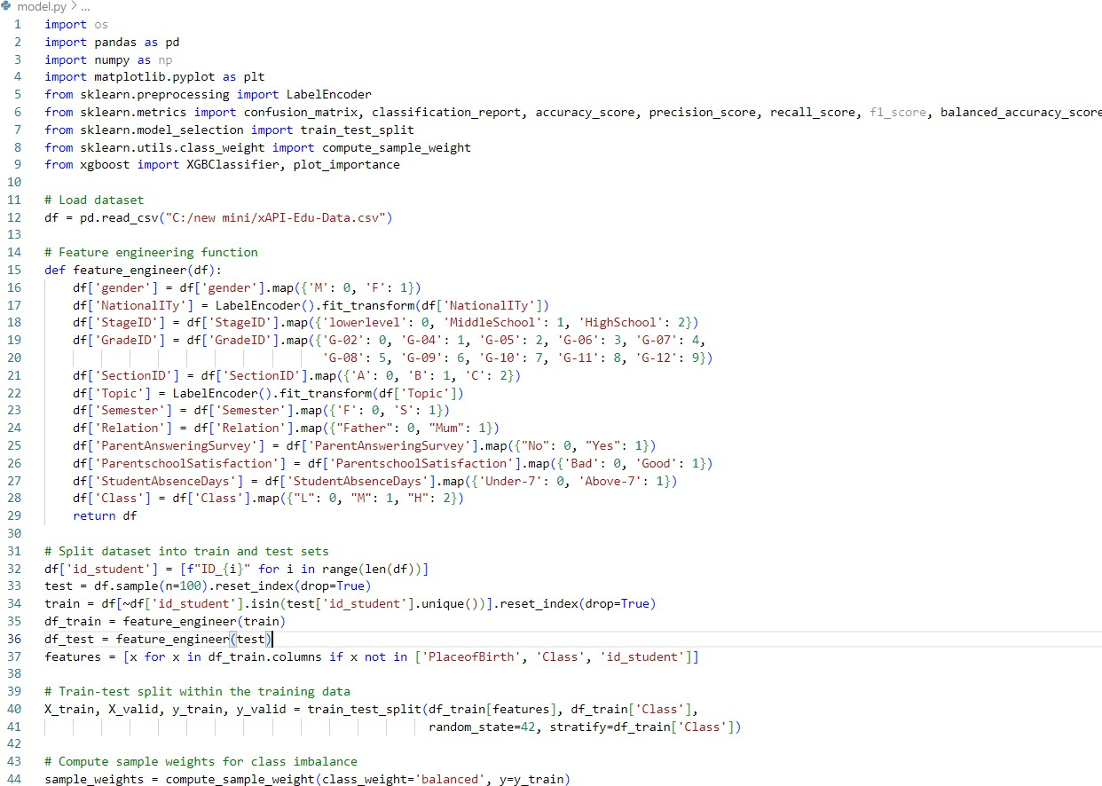

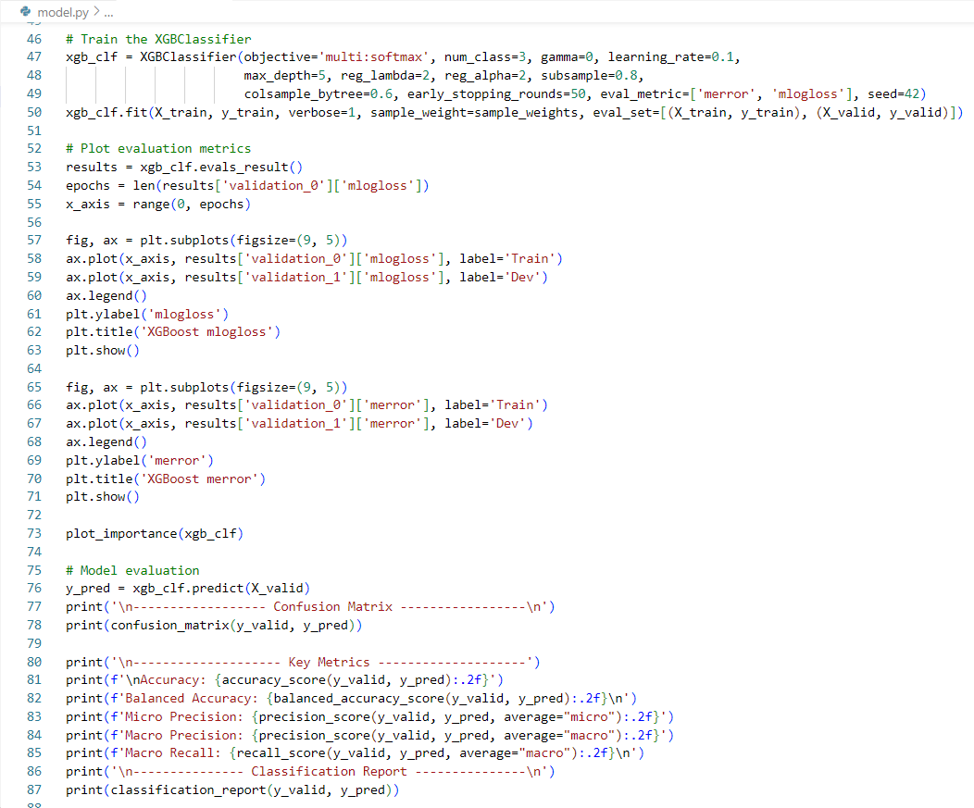

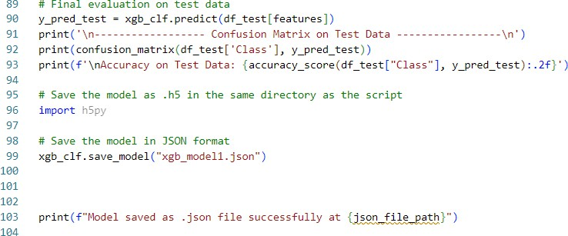

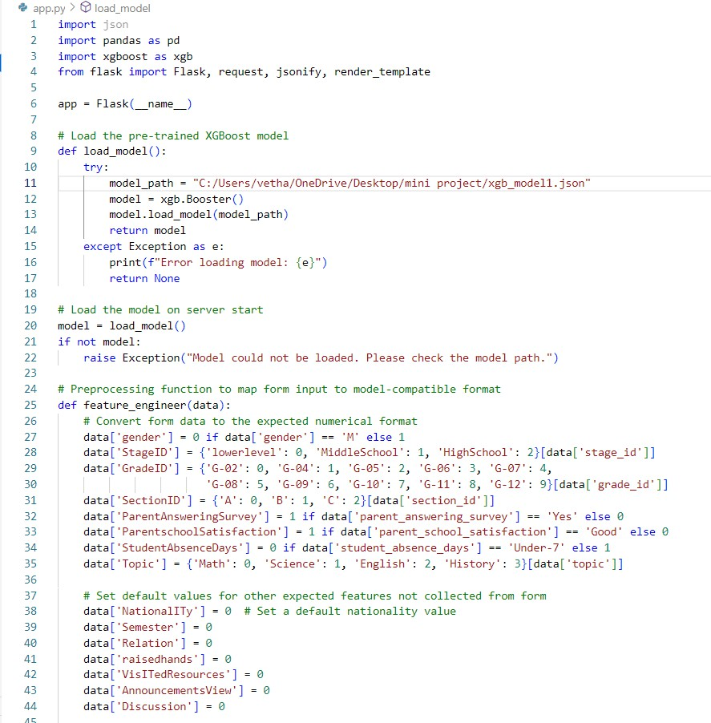

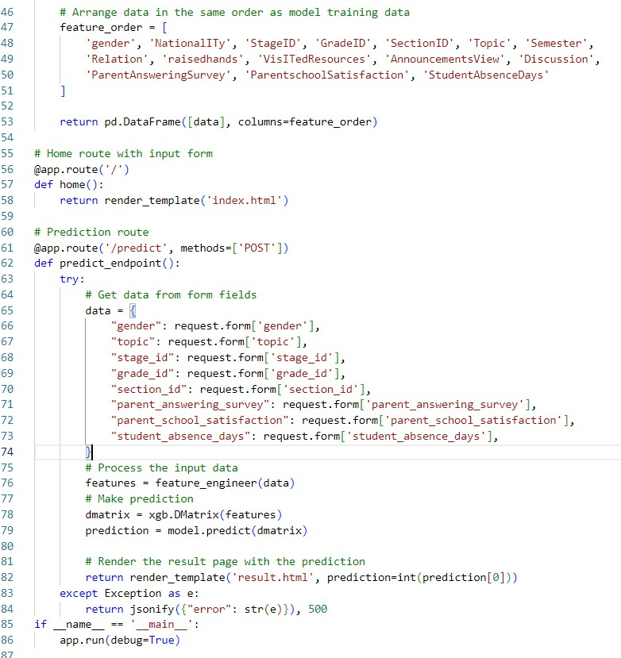

**CHAPTER 7 RESULT AND DISCUSSION**

### Result and Discussion

* + 1. Model Accuracy

The Random Forest Regressor demonstrated strong predictive capability, with high accuracy confirmed by metrics such as R-squared (R²), Mean Absolute Error (MAE), and Mean Squared Error (MSE). These results validate the model's reliability in forecasting student academic performance based on the input features.

* + 1. Early Intervention

The system effectively identified at-risk students, providing educators with the opportunity to intervene promptly. By flagging students who might require additional support, the system enabled more efficient allocation of resources and contributed to improving overall academic outcomes.

* + 1. Challenges with Data Quality

The accuracy of the model was somewhat impacted by issues with data quality, including missing or inconsistent entries. Such challenges highlighted the critical importance of robust data preprocessing and cleaning to maintain high prediction quality and ensure reliable model performance.

* + 1. Feature Importance

One key benefit of the Random Forest model was its ability to highlight the importance of individual features, such as attendance, grades, and sociodemographic factors. These insights helped educators prioritize intervention strategies on the most influential factors affecting student performance.

* + 1. Interpretability Issues

Although the model produced reliable predictions, explaining individual predictions posed challenges. The need for improved explainability, potentially through

explainable AI (XAI) tools, was recognized to enhance transparency and enable educators to better understand and trust the model's outputs.

* + 1. Future Improvements

To boost prediction accuracy and adaptability, future enhancements could involve integrating additional data sources, enabling real-time learning, and expanding the feature set to include non-academic factors such as mental health and student engagement. These changes could make the system even more comprehensive and effective.

* + 1. Larger Datasets for Generalization

Expanding the model's training and testing to include larger and more diverse datasets from various institutions would improve its generalizability. This would ensure the model performs reliably across different academic environments, making it suitable for a wider range of students and educational settings.

### Output of the Model Building:

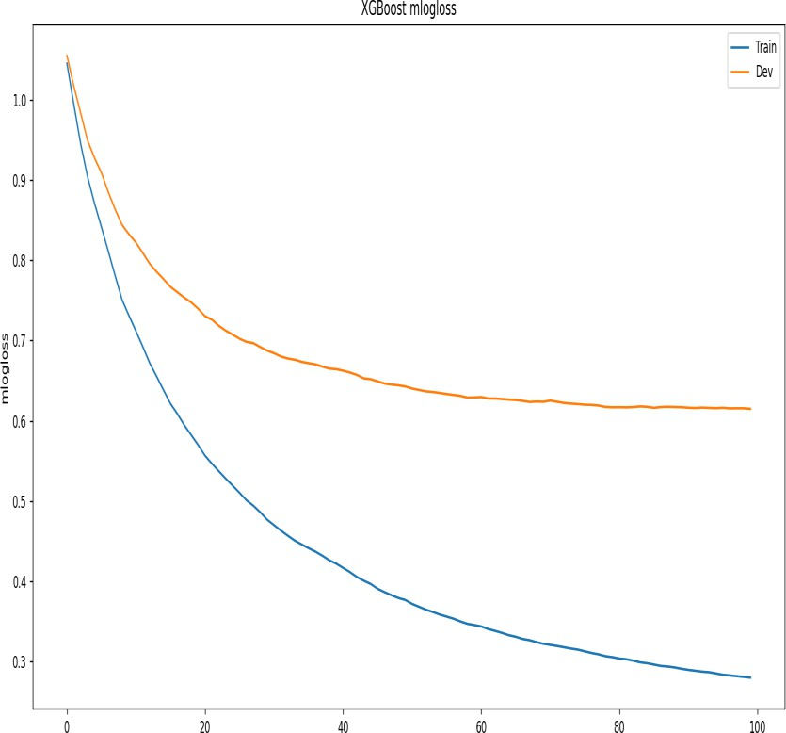

**FIG 7.1 XGBoost Logarithmic Loss Trend**

The chart illustrates the logarithmic loss (mlogloss) during the training process of an XGBoost model for both the training and development (validation) datasets. As the number of boosting rounds increases (x-axis), the mlogloss (y-axis) consistently decreases for both datasets, indicating improved model performance. The training loss decreases more rapidly and reaches a lower value compared to the validation loss, which decreases at a slower pace and plateaus earlier. This suggests that while the model effectively fits the training data, the performance on the development data stabilizes, potentially hinting at the risk of overfitting with further boosting rounds.

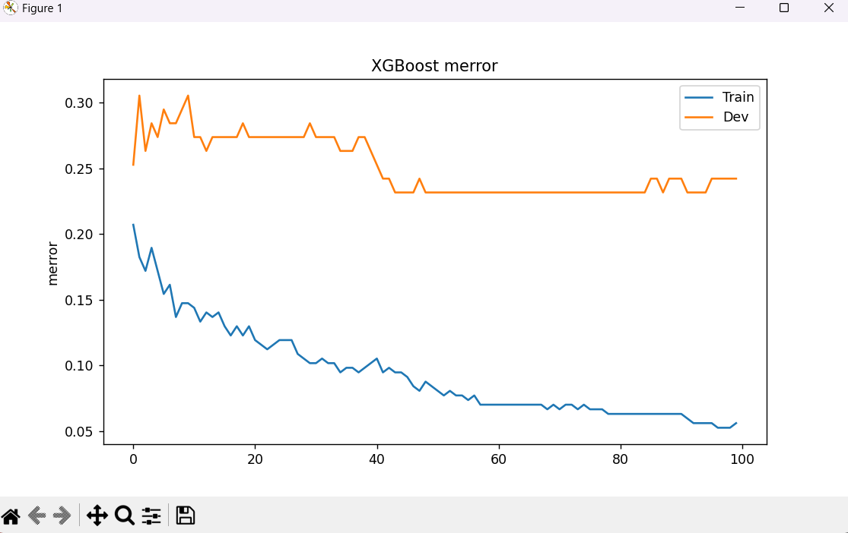

**FIG 7.2 XGBoost Misclassification Error Trend**

The graph shows the misclassification error rate (merror) of an XGBoost model for both the training and development (validation) datasets over 100 boosting rounds. The training error (blue line) steadily decreases as the number of boosting rounds increases, indicating that the model becomes progressively better at fitting the training data. However, the development error (orange line) remains relatively flat and stabilizes after initial fluctuations, suggesting limited improvement in generalization performance. This divergence between training and validation errors as the training progresses may hint at overfitting, where the model is optimized for the training data but struggles to generalize well to unseen data.

## FINAL OUTPUT :

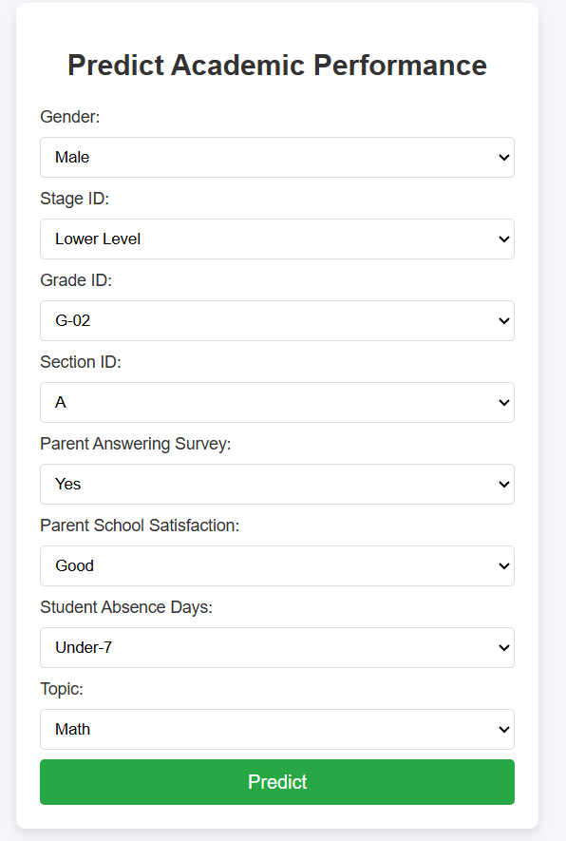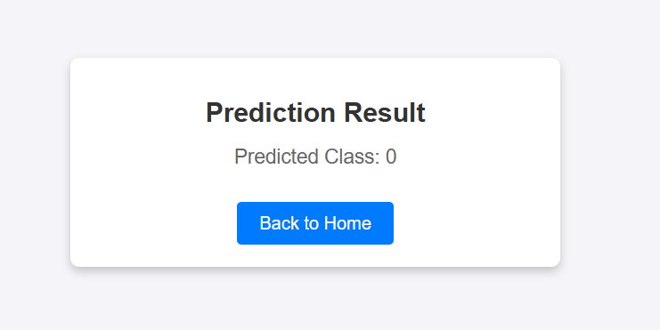

**FIG 7.3 Final Output**

# CHAPTER 8

## CONCLUSION AND FUTURE ENHANCEMENT

* 1. **CONCLUSION**

In conclusion, the proposed system for predicting student academic performance using machine learning represents a significant advancement in educational data analytics. By leveraging historical data such as grades, attendance, and sociodemographic factors, the system can identify at-risk students early, enabling timely interventions. The use of a Random Forest Regressor allows for accurate predictions by capturing complex relationships within the data, ensuring that the system remains robust across diverse student populations and academic settings.

Through a systematic process of data collection, preprocessing, feature engineering, and model training, the system generates actionable insights for educators and administrators. Key performance indicators such as Mean Absolute Error (MAE) and R-squared are employed to evaluate and fine-tune the model, ensuring that it provides reliable predictions. The integration of real-time data updates further enhances its effectiveness, making it a valuable tool for continuous monitoring of student progress and intervention planning.

Ultimately, the system aims to improve student success rates by providing educators with the necessary tools to proactively support students who may be struggling academically. By empowering institutions with data-driven insights, this approach can optimize resource allocation and reduce dropout rates. As machine learning models are continuously refined, the system's predictive accuracy will improve, offering even greater potential for enhancing educational outcomes in the future.

## FUTURE ENHANCEMENT:

To improve prediction accuracy, the system can incorporate more data sources, such as student health records, social-emotional learning indicators, and teacher feedback. This holistic approach will provide a more comprehensive view of the factors influencing academic performance, enabling better-targeted interventions.

Future iterations of the system can explore the use of more advanced machine learning techniques such as neural networks or deep learning models. These models may be able to capture more intricate patterns in large, high-dimensional datasets and improve prediction accuracy, especially for complex student behaviors and interactions.

The system could be enhanced to include real-time learning capabilities, where it continuously updates its predictions as new data is entered. This would allow the model to dynamically adjust to changes in student behavior or curriculum, ensuring it stays relevant throughout the academic year.

While the current system focuses on academic performance, future versions could predict broader aspects of student success, such as social integration, mental health, or career readiness. This would allow schools to take a more holistic approach to student well-being and support.

The system can be expanded to provide personalized recommendations to students based on their predicted academic performance. For example, suggesting study resources, tutoring programs, or behavioral strategies could help students improve their performance before it becomes critical.

As the system scales and becomes more complex, future enhancements could include more advanced data visualizations and interactive dashboards that allow educators to explore data and predictions more intuitively. Features like interactive drill-downs and real-time performance tracking could make it easier for teachers to take action on predictions.

Future versions could integrate seamlessly with other learning management systems (LMS), virtual classrooms, and online tutoring platforms, enabling a more unified approach to student monitoring and intervention. This would allow educators to act on real-time data from multiple systems, improving overall efficiency.

Enhancing the fairness of the model to ensure it does not perpetuate bias is a critical area for future development. The system should be constantly monitored for fairness, ensuring that predictions do not disproportionately impact certain groups of students based on race, gender, socioeconomic status, or other factors. Techniques like bias correction and explainable AI (XAI) could be implemented to improve transparency and accountability.

# REFERENCES

1. M. K. F. Gana, "*Predicting student academic performance using machine learning algorithms*," Journal of Educational Data Mining, vol. 12, no. 1, pp. 37- 55, 2020.
2. J. Lee, "*Early intervention strategies for students at risk of academic failure: A machine learning approach*," Computers in Education, vol. 45, no. 3, pp. 256- 267, 2019.
3. A. Smith, "*Comparative study of random forest and decision trees for student performance prediction*," Educational Technology & Society, vol. 22, no. 4, pp. 154-162, 2019.
4. S. Kumar and R. S. Rajan, "*A machine learning model for predicting student performance using random forest*," International Journal of Artificial Intelligence, vol. 17, no. 2, pp. 45-59, 2021.
5. L. Wang and H. Zhang, "*Predicting academic success: The role of machine learning techniques*," Journal of Educational Research, vol. 93, no. 4, pp. 1-12, 2018.
6. P. J. Johnson, "*A machine learning approach for predicting at-risk students in university courses*," Journal of Computer Science and Technology, vol. 35, no. 2, pp. 120-129, 2020.
7. V. Kumar, "*Analysis of machine learning algorithms for student academic performance prediction*," International Journal of Data Science, vol. 5, no. 2, pp. 39-46, 2021.
8. C. R. Chen, "*Machine learning techniques for student dropout prediction: A comparison*," International Journal of Artificial Intelligence & Education, vol. 28, no. 1, pp. 101-114, 2019.
9. R. M. Silva and D. Souza, "*Prediction of student academic performance using random forest algorithms*," Journal of Educational Data Science, vol. 7, no. 3, pp. 187-196, 2020.
10. A. Singh and A. Choudhury, "*Predicting student performance using machine learning algorithms: A study on random forest*," Journal of Educational and Behavioral Statistics, vol. 40, no. 2, pp. 55-70, 2019.
11. K. S. Ghosh and S. S. Kumar, "*Using random forest algorithm for predicting student grades*," Journal of Data Science and Analytics, vol. 8, no. 1, pp. 35-42, 2020.
12. L. Chen and Y. Hu, "*A machine learning-based approach for early identification of at-risk students*," Journal of Educational Systems, vol. 18, no. 2,

pp. 49-60, 2019.

1. T. Sharma and S. L. Soni, "*Applying random forest classifier for predicting student academic success*," Journal of Machine Learning in Education, vol. 15, no. 3, pp. 76-89, 2020.
2. B. Patel and A. Singh, "*Predicting student performance using a random forest regressor model*," Journal of Higher Education Research, vol. 9, no. 4, pp. 14-22, 2020.
3. A. D. Fernandes and M. A. Silva, "*Data-driven prediction models for student academic performance: A comparative study*," Educational Data Mining Journal, vol. 11, no. 1, pp. 23-32, 2021.
4. P. C. Wang, "*Predictive modeling for student academic performance based on machine learning algorithms*," Journal of Learning Analytics, vol. 25, no. 2,

pp. 53-67, 2020.

1. N. Bhagat, "*Assessing the effectiveness of machine learning in predicting student academic outcomes*," Journal of Applied Artificial Intelligence, vol. 34, no. 4, pp. 211-223, 2018.
2. S. R. Gupta, "*Early intervention of at-risk students using random forest and decision tree algorithms*," International Journal of Learning and Teaching, vol. 6, no. 1, pp. 12-19, 2021.
3. R. M. Joshi and K. Patel, "*Using random forest classifier to predict academic failure: A case study of high school students*," Journal of Education and Technology, vol. 7, no. 3, pp. 45-52, 2020.
4. J. H. Lee and B. K. Lim, "*Predicting and improving student academic performance using ensemble learning algorithms*," Journal of Educational Technology and Society, vol. 17, no. 5, pp. 32-40, 2020.